**Capstone Project: Relational Database**

**Product Dissection for Top Leading Platforms**

**Platform Chosen: Instagram**

**Step 1: Leading Platform Overview**

**Platform:** Instagram  
**Founded:** 2010 by Kevin Systrom and Mike Krieger  
**Domain:** Social Media / Visual Content Sharing

Instagram is a global platform that allows users to share photos, videos, and stories, connecting millions through visual storytelling. It has transformed the way people express themselves, build communities, and discover trends. With over a billion users, Instagram continues to be a leader in digital engagement and creativity.

**Step 2: Research – Understanding Instagram**

**Core Features:**

1. User profiles with bio, username, and media gallery.
2. Post creation with captions, images/videos, and geotags.
3. Social interactions — likes, comments, and followers.
4. Hashtags for content discovery.
5. Explore feature for personalized recommendations.
6. Follower–following relationships for user connectivity.

**User Interactions:**  
Users can register, create posts, follow others, like posts, comment, and tag hashtags — forming a rich network of multimedia engagement.

**Step 3: Product Dissection and Real-World Problems Solved**

|  |  |
| --- | --- |
| **Problem** | **Solution by Instagram** |
| Lack of genuine connection in online communication | Enables **visual storytelling** through photos and videos to express real emotions. |
| Difficulty in discovering relevant content | Uses **Explore & Hashtag features** for content curation and discovery. |
| Limited creative space for individuals | Provides creators tools to showcase their talents and monetize their audience. |
| Limited personal branding options | Allows personalized profiles with bios, highlights, and visual themes. |

Instagram bridges the emotional gap in online interaction and empowers users to communicate visually, addressing challenges of connection, discovery, and creativity.

**Step 4: Case Study – Real-World Problems and Approach**

**Case 1: Digital Disconnect**

**Challenge:** Users felt that text-based interactions lacked emotional impact.  
**Solution:** Instagram’s multimedia posts (images, videos, stories) enable expressive, authentic communication that fosters stronger connections.

**Case 2: Information Overload**

**Challenge:** Users were overwhelmed by random content on social platforms.  
**Solution:** The “Explore” page uses algorithms to recommend relevant posts, reducing content noise.

**Case 3: Creator Economy**

**Challenge:** Creators needed a platform for visibility and growth.  
**Solution:** Instagram offers profiles, hashtags, and insights that help users grow audiences and build personal brands.

**Step 5: Schema Design Based on Top Features**

**Key Entities and Attributes**

|  |  |  |
| --- | --- | --- |
| **Entity** | **Attributes** | **Description** |
| **User** | UserID (PK), Username, Email, Full_Name, Bio, Registration_Date | Stores user profile information. |
| **Post** | PostID (PK), Caption, Image_URL, Location, Post_Date | Represents user posts shared publicly or privately. |
| **Comment** | CommentID (PK), Text, Comment_Date | Holds comments on posts. |
| **Like** | LikeID (PK), Like_Date | Tracks user likes on posts. |
| **Follower** | FollowerID (PK), Follow_Date, FollowingUserID (FK), FollowerUserID (FK) | Represents follower-following relationships. |
| **Hashtag** | HashtagID (PK), Tag | Stores unique hashtags used in posts. |
| **PostHashtag** | PostHashtagID (PK), PostID (FK), HashtagID (FK) | Manages many-to-many relationships between posts and hashtags. |

**Step 6: Rationale Behind the Design**

1. **Normalization:** Each entity stores unique data to reduce redundancy.
2. **Scalability:** Separate tables for Likes, Comments, and Followers allow millions of records to scale efficiently.
3. **Flexibility:** Many-to-many relationships (Posts ↔ Hashtags) improve tagging and content discovery.
4. **User-Centric Structure:** User is the central entity linking posts, comments, and likes, reflecting real platform logic.
5. **Data Integrity:** Primary and foreign keys ensure referential consistency across the schema.

**Step 7: ER Diagram**

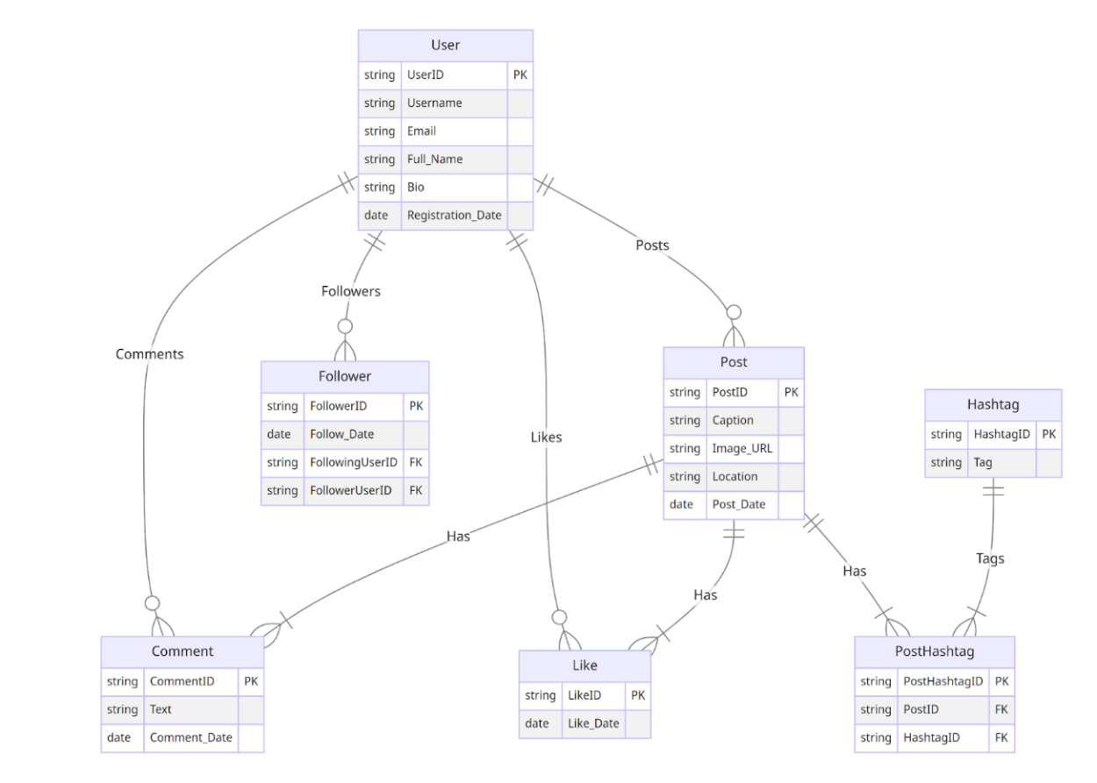

**Diagram Summary:**

* Each **User** can create many **Posts**, like or comment on multiple posts, and follow other users.
* Each **Post** can have multiple **Likes**, **Comments**, and **Hashtags**.
* **Hashtags** link through a junction table **PostHashtag**.
* Relationships are many-to-many between users and posts, and between posts and hashtags.

**Step 8: Presentation of Findings**

**Summary of Insights:**

* Instagram’s schema is centered on **User Engagement and Content Relationships**.
* The relational design efficiently models social connections and multimedia sharing.
* Data architecture supports millions of interactions daily while maintaining fast retrieval and scalability.

**Impact:**

The schema design enhances user experience through:

* Efficient content retrieval.
* Accurate personalization (Explore recommendations).
* Seamless relationship tracking (followers, likes, and hashtags).

**Step 9: Presentation Video**

**Video Link:** *(Add your Google Drive or YouTube link here)*

Your presentation should:

* Explain Instagram’s background and challenges.
* Walk through each entity and its relationship.
* Highlight how schema design supports the platform’s success.
* Conclude with key takeaways.